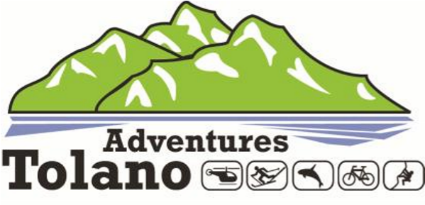

Tolano Adventures provides eco-friendly travel services to a growing market. All our tours meet stringent requirements to ensure these adventures have the lowest carbon footprint and are environmentally friendly. At Tolano, we are pleased to be achieving our goal to “go green” at every opportunity.

Tolano Adventures is a division of Tolano Environment Consulting, based in New York. We also have Travel Directors at international locations to serve you better.

We work with a number of international vendors and are always looking for new and exciting adventures. Each new adventure is reviewed by our Site Assessor along with the Travel Director to ensure it meets our standards for being ecological while offering maximum enjoyment and opportunities for participation.

We review all our tours annually to ensure that:

* they have a low environmental impact (particularly the more popular ones)
* there is no significant change in their environmental impact compared to the previous year
* guests are still getting maximum enjoyment from them
* the cost is reasonable compared to the number of bookings and environmental impact

Occasionally we will also review a tour if there has been a noticeable change or danger such as an avalanche, an earthquake, or other natural disaster.

Some of the more popular tours we offer include:

* + Rock or Ice Climbing
  + Heli-skiing
  + Hot Air Ballooning
  + Whale Watching
  + Cycling

For more information about the exciting tours we offer, visit us at [www.tolanoadventures.com.](http://www.tolanoadventures.com)